# AI for Good

**Module 5**

**Table of Contents**

**AI for Good 1**

Learning Objectives 5

**AI For Earth 5**

Sustainability for global fishing 5

Satellite imagery for forest management 7

Enabling precision conservation and sustainable agriculture practices 8

Climate related risk 10

**AI For Cultural Heritage 11**

Preservation and enrichment of cultural heritage around the world 11

Engaging with communities around the world for language preservation 14

Using digital tools to preserve historical artifacts, paintings, and other works of art 16

**AI For Accessibility 17**

Features of the App: 17

**AI for Humanitarian Action 18**

Use AI-based recovery programs designed for disasters and emergencies 18

Monitor, detect, and prevent human rights violations 18

Ensure the safety and well-being of children around the world 19

Using speech-to-text AI and an Azure database to advocate for people seeking asylum 19

Improve surgical outcomes of facial surgeries and help more children 19

**Questions to Ponder Upon 21**

**References 22**

**Glossary 24**

**Disclaimer:**

The Imagine Cup Junior guides and lesson materials are created by Microsoft and our partners and intended to be for guidance only to support with the Imagine Cup Junior Challenge. For the latest on Microsoft AI please visit <https://www.microsoft.com/en-us/ai>

Learning Objectives

*At the end of the module students will be expected to:*

* Understand the various ways AI can be used to make learning and life easier for the less privileged.
* Understand the severity of people’s actions and the toll it takes on the overall earth.
* Appreciate Microsoft’s collaboration with various small, medium and large-scale organizations to ensure that its Azure suite of applications are utilized well for the benefit of all.

AI For Earth

How often have you heard that species of flora and fauna are facing extinction? Or forests are being cut down to create dwellings or factories? In these examples we find that due to gross exploitation of the natural resources of Earth, biodiversity is greatly affected. Animals, birds, and insects are losing their habitats, as we move in and decimate them for our own purpose. There are many areas on the Earth which are inhospitable for humans to live comfortably due to their hostile climatic conditions. However, this must not prevent us from conserving the flora and fauna at these places

It is important for us to help preserve their habitats to conserve them. Together they maintain the balance of natural resources and the food cycle on Earth. The aim of using AI algorithms for the Earth is to create sustainable solutions across four areas, namely – water, biodiversity, agriculture, and climate change. These areas hold the key to the health of our planet and subsequently, the future of mankind.

In this sub module, we will explore the various partnerships that organizations have made with Microsoft to use their Azure cloud suite of services to help people save the planet.

# Sustainability for global fishing

According to the University of British Columbia, “countries drastically under report the number of fish caught worldwide. The new estimate released puts the annual global catch at roughly 109 million metric tons, about 30% higher than the 77 million officially reported in 2010 by more than 200 countries and territories. This means that 32 million metric tons of fish goes unreported every year, more than the weight of the entire population of the United States”.

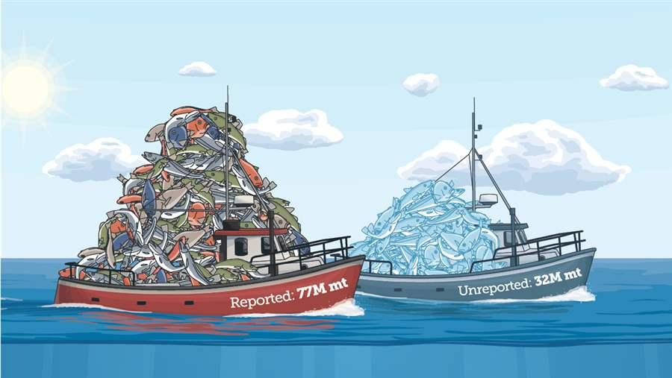

Fig 5.1: Reported and Unreported Fishing Data

Image source :(<https://www.pewtrusts.org/en/research-and-analysis/articles/2016/01/19/scientists-find-that-30-percent-of-global-fish-catch-is-unreported>, 2019)

The current challenge that the fishing industry is facing is the exploitation of our marine ecosystems, thus pushing many aquatic species towards extinction. Our oceans, seas and other water bodies are sources of food and livelihood to many people. The contamination of these water bodies through pollutants and plastic waste is detrimental not only to humans but also to the marine ecology.

OceanMind is one of many partners who, along with Microsoft, works with government agencies to protect fishing stock, store data on fishing vessel’s positions in the cloud and track each one in real-time. It uses sophisticated AI algorithms and Microsoft Azure suite of services to analyze the movements of the ship and identify any demonstrating suspicious behavior. This could include staying still in one place for too long, venturing into an area of water where they are not permitted, or going off an established route. OceanMind as a partner is committed to preserving the marine biodiversity of our oceans. The partnership uses satellites and AI to help preserve biodiversity, protect livelihoods, and prevent slavery in the seafood industry.

# Satellite imagery for forest management

Conserving our forests and what is they contain (plants, animals, birds, insects etc.) will help us not only preserve its biodiversity but also help in tackling the challenges of global warming. It is essential to monitor our forests and the land they take up. Artificial Intelligence plays a particularly important role in such a scenario. SilviaTerra, an organization involved in forest management, together with Microsoft uses the Microsoft Azure suite of services to analyze high-resolution satellite imagery, the US Forest Service inventory, and field data in order to train machine-learning models to record relevant data of the forests and predict future scenarios.

“SilviaTerra is a small team of foresters, biometricians, and programmers dedicated to expanding the understanding of forests and strengthening our ability to manage these complex and vital ecosystems.”

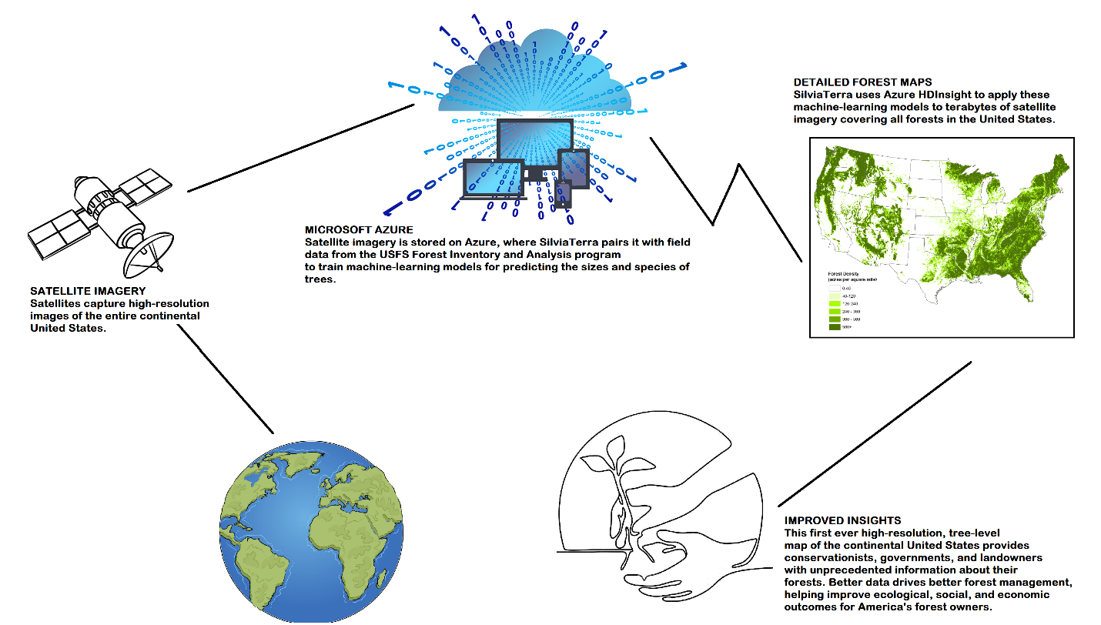

Fig 5.2: Using Satellite imagery for forest management

[Video: Mapping the future of our forests with Microsoft AI](https://youtu.be/stNlw_CFklc)

SilviaTerra uses the following Azure services:

* Virtual machines to run its imagery processing pipeline.
* HDInsight clusters to scale its forest inventory prediction models across the entire continental United States at 15m resolution.
* Key Vault to securely store and distribute credentials to the runtime environments.
* Blob Storage to hold terabytes of remotely sensed imagery including processed Landsat, DEM, and radar data.

# Enabling precision conservation and sustainable agriculture practices

In today’s age, as resources become scarce, it is imperative to ensure that we use the available resources in the best and most efficient way possible. In order to achieve this goal we should adopt sustainable agricultural practices such as precision farming or precision agriculture.

Precision farming can be understood as “the practice of farming by the more accurate and controlled growing of crops and raising livestock. A key component of this farm management approach is the use of information technology and a wide array of other technologies such as Global Positioning System (GPS) guidance, control systems, sensors, robotics, drones, autonomous vehicles, and GPS-based soil sampling,”.

It was John Deere who first introduced precision farming to the world of agriculture. He used the GPS location data from satellites to automatically steer the tractor based on the mapped coordinates of the field. This decreased steering errors by drivers and therefore resulted in less waste of the farmer’s resources such as seeds, fertilizer, fuel, and time.

Another term that needs to be understood in the same context is precision agronomics, which means to provide accurate farming techniques for the planting and growing of crops, and involves the following:

* **Variable rate technology** – the variable application of deliverables (fertilizer, herbicides etc.) Allows farmers to control the amount of deliverables to a specific location.
* **GPS soil sampling** – the testing of soil to reveal the level of available nutrients, pH level, and a range of other data important to make informed decisions on planting and soil maintenance.
* **Computer-based applications** – the creation of precise farm plans, field maps, crop scouting, and yield maps, allowing precise application of deliverables such as pesticides, herbicides, and fertilizers. It reduces expenses, produces higher yields, and creates a more environmentally friendly operation.
* **Remote sensing technology** – a tool to monitor and manage land, water, and other resources. Data gathered by this device enhances decision-making on the farm and comes from several sources including drones and satellites.

How does precision farming benefit farmers, and why should they choose it over traditional ways of farming? Here are a few reasons which makes it amply clear as to why precision farming is more beneficial over the age-old methods of farming:

* Increases agricultural productivity.
* Prevents soil degradation.
* Reduces the application of chemicals in crop production.
* Efficient use of water resources.
* Dissemination of modern farm practices to improve quality, quantity and reduced cost of production.
* Develops favorable attitudes.
* Changes the socio-economic status of farmers.

The video below provides a brief overview of how precision agronomics helps farmers.

[Video: Drones, scanners and GPS all part of 'precision farming' arsenal](https://youtu.be/tEj__Vo1WxQ)

Ag-Analytics partners with Microsoft in using sensors to collect soil, tillage, and yield data from specific plots of farmland. The data is stored in the Microsoft Azure cloud and is made available to farmers via user-friendly APIs to help them lower costs, improve farm yields, and minimize the ‘environmental cost’ of agriculture.

# Climate related risk

One of the many changes that we see happening is global warming and its impact on climate change. Climate change is one of the biggest challenges that the world has ever faced. The consequences are enormous and are affecting not only we humans but also flora and fauna globally.

Subject experts passionately believe that AI can help us in this situation. Machine learning can be deployed to help tackle various challenges in the field of lessening carbon footprint, solar geo-engineering, educating the global population etc., which in turn can help in the cause of deforestation and creating energy efficient materials, thus a greener Earth. Though AI is not be a ‘solution’ to the problem, it can surely contribute to making the situation better in many ways. AI can help provide us with climate informatics, which is an amalgamation of aspects such as the prediction of extreme events, paleoclimatology, climate downscaling, and even large-scale models to predict weather.

Given the fact that deep learning algorithms learn from their own past data and evolve internally to produce ever better results, the predictions and forecast will improve with time. It is important to accept that AI is faster and can produce better results. Therefore, it will help people make better decisions, prepare them to tackle global problems, and reduce the impact brought about by climate change to some extent.

One of the many reasons for climate change is the level and extent of carbon dioxide in the atmosphere. It is, therefore, important that we understand and trace out the various sources of carbon dioxide. In particular, it is necessary to measure the amount of carbon dioxide that gets released in the air from various sources in order that we can find either alternatives to curb the emission or shut down the causes. ‘Carbon Tracker’ is an independent financial think-tank working towards the United Nations goal of [preventing new coal plants from being built](https://www.unenvironment.org/resources/emissions-gap-report-2018) from 2020. By monitoring coal plant emissions with satellite imagery, Carbon Tracker can use the data it gathers to convince the finance industry that these sorts of plants aren't profitable.

AI For Cultural Heritage

Thinking of AI as a medium which changes our lives, what examples can you think of? Often the examples are chatbots, AI-powered personal digital assistants, apps working on sophisticated behavioral algorithms, AI-powered drones, self-driving cars, shopping bots, etc.

Recently, Microsoft has decided to explore and invest in the use AI to benefit mankind from an art and cultural perspective. This could change the way in which future generations view cultural icons and engage with their heritage. It is aimed at both the preservation of culture and making it more accessible to people.

In this endeavor, specific interest groups with domain expertise, work together to help preserve our cultural heritage in collaboration with local governments. A few notable examples include recreating an experience of the lifestyle, spoken languages and culture heritage of the past. The preservation of near-extinct languages, places, lifestyle and artifacts that we treasure as pieces of art, and the celebration of people who have made a lasting impact on the history of mankind and scientific evolution.

# Preservation and enrichment of cultural heritage around the world

­­­­­­­­­­­­­­­­­­­­­­In ancient times, going on a voyage was a matter of great concern as there were no maps. People had to rely on the North Star, the sun and the constellations to navigate. Though maps are known to have existed as early as 2300 BCE on Babylonian clay tablets, cartography became a full-fledged science only during the era of the Greeks.

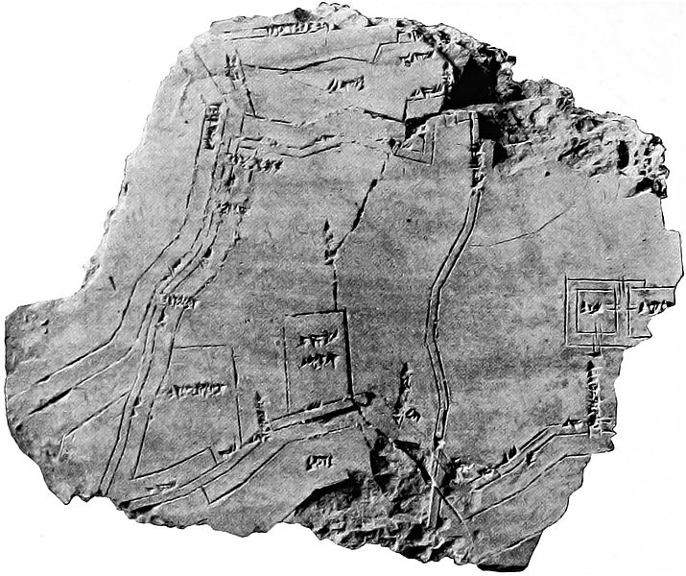

Fig 5.3: Oldest existing map engraved on this mammoth tusk, dated 25,000 BC

Ptolemy is one of the most prominent Greek astronomers and geographers of his time. It is he who created the first world map by depicting the ‘Old World’ from about 60°N to 30°S latitude. In France during the 17th and 18th centuries there was a trend of making 3D maps. These were large scale maps that were painstakingly precision built. Rulers of the time such as Napoleon and King Louis XVI considered them a strategic tool and as such kept them hidden from public view.

However, in modern times, many of these maps have been destroyed due to the passage of time, civil unrest, or war etc. The Musée des Plans-Reliefs in Paris has partnered with Microsoft, HoloForge, and Iconem to create “The Mont Saint-Michel: Digital perspectives on the model,” a HoloLens experience to celebrate French culture and innovation. The goal of this exhibit is to use augmented (mixed) reality technology in a way that empowers the Musée des Plans-Reliefs to unlock a more vivid kind of storytelling. The model of Mont-Saint-Michel is a rocky headland just off the Normandy coast that is home to a Benedictine abbey of architectural beauty in its own right and was presented by a monk to Louis XIV in 1701. This HoloLens experience is bringing both the relief map and Mont-Saint-Michel itself, to life without even physically visiting France.

As you can see, AI is being used for the good of humanity in providing access and promoting a greater understanding of the rich and diverse cultural heritage of humankind throughout the ages.



Fig 5.4: Mont Saint-Michel near the Normandy coast, France

Click on the link below to know more:

[Video: Le Mont-Saint-Michel en 3D (no sound)](https://youtu.be/eajawgk3Fd8)

# Engaging with communities around the world for language preservation

In a world where more than 7000 languages are spoken, only a handful of languages are spoken by a large percentage of the population. One third of these languages have fewer than 1,000 people who continue to speak them. In southwestern Mexico, Microsoft is engaged as one of the community partners to preserve spoken languages in the region, specifically *Yucatec Maya* and *Queretaro Otomi*.

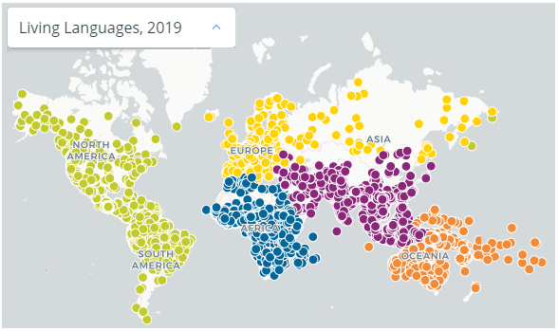

Fig 5.5: Map by Ethnologue by SIL International (Ethnologue, 2019)

According to the Expanded Graded Intergenerational Disruption Scale (EGIDS), 2,895 languages are endangered today. A language is considered endangered when it is not spoken or taught as a dominant language. Very often, such languages are spoken by the older generation, but the younger generation are unaware of them. There have been instances in the past where the last known speaker of an endangered language died, and the authorities had no knowledge about it. Languages are stable when members of a community learn and practice the language as a medium of communication both within and outside their community.

An Institutional language such as English, Spanish, Chinese, Japanese and many, many more is least likely to become endangered as it has been adopted by governments, schools, the mass media, and also potentially as a dominant second or even tertiary language as is the case with Belgium where they speak French, Dutch and German officially but have minor languages such as Flemish. Similarly, in Wales, where it has revitalized its ancient Celtic language and as such both Welsh and English are spoken in schools.

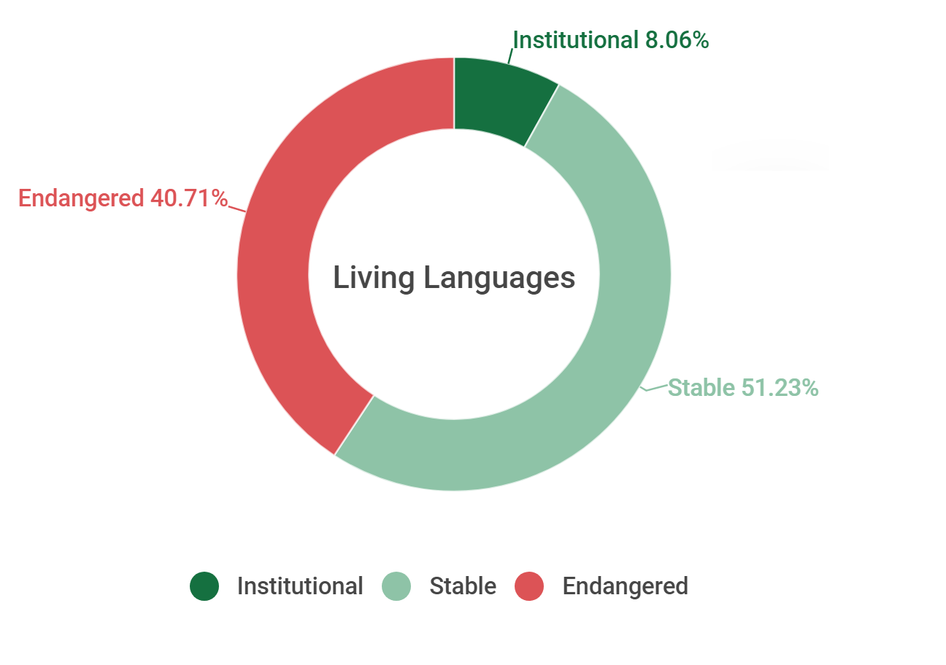

Fig 5.6: Segregation of languages according to EGIDS measurement tool

Companies such as Microsoft recognize the gravity of losing the heritage of a language and have thus introduced languages such as *Yucatec Maya* and *Querétaro Otomi* in their list of supported languages in Microsoft Translator. This allows automatic translation to permanently bridge the translation gap between these endangered languages and the rest of the world. The systems were built using the Microsoft Translator Hub, a translation product which is available for free to allow any group to create its own unique translation systems. Even fictional languages such as Klingon from the TV Star Trek Series has been added to the Translator and has been available in Bing Translate since 2003.

Native to the Yucatan region of Mexico and Belize and descended from the language of the ancient Mayan empire, *Yucatec Maya* is spoken by fewer than 800,000 people, with less than 59,000 monolingual speakers. *Querétaro Otomi* is an endangered language from the State of Querétaro, in western central Mexico that is only spoken by 33,000 people and has fewer than 2,000 monolingual speakers.

Watch the video below to find out more about Microsoft Language Hub

[Video: Microsoft Translator Hub: Translation by Everyone for Everyone](https://youtu.be/-ylJ80quXcs)

# Using digital tools to preserve historical artifacts, paintings, and other works of art

According to the Internet Encyclopedia of Philosophy, “Interpretation in art refers to the attribution of meaning to a work”. In order to interpret a work of art there are two prevalent concepts of isolationism and contextualism.

The project aims to make art all over the world accessible and discoverable by all. In order to complete this task, it is therefore important to digitize, classify, and tag these works of art in a scalable manner. To demonstrate the scale of such a project, the Metropolitan Museum of Art alone has over 1.5 million works of art from more than 5,000 years ago. In collaboration with Microsoft, the museum launched its Open Access platform in 2017. The aim was to make the art collection more accessible to people not only physically, but also over the Internet. The joint effort uses AI to assist people in appreciating and developing a meaningful connection with these art pieces. Since it is a labor-intensive process, Microsoft and the Museum have jointly decided to make use of Microsoft’s Cognitive Search to examine each artwork. This generates the necessary information to create relevant tags and classify the artworks in a fraction of a second.

Watch the following video to find out more about a hackathon based on this project.

[Video: How Gen Studio was created for The Met using Microsoft AI](https://youtu.be/9etxRT1hq14)

The process is quite intense and involves uploading images of the artwork into Art Explorer, after which the cognitive search returns not only the wealth of information that it can gather from the Internet but also visually similar or related local information on the artwork. The results are then arranged into a searchable index for better comprehension and clarity, insights and finds relationships between various pieces of the collection.

AI For Accessibility

This program provides deserving organizations and people with a variety of disabilities access to the advanced Microsoft suite of services in order to support them in creating solutions to everyday activities and in many cases increase quality of life. The aim is to provide an Accessibility program that awards grants to projects which build on recent advancements in Microsoft Cognitive Services and Machine Learning to develop accessible and intelligent AI solutions in any of the following three areas of focus. These three areas are:

* **Employment** - How can AI positively impact the employment rate for people with disabilities by their use of more intelligent technology?
* **Daily Life** - How can AI increase access to technology for people with disabilities, while at the same time decreasing the cost of such technology?
* **Communication & Connection** – How can AI help improve the speed, accuracy, and convenience of communication for people with disabilities?

The free app Microsoft SEEING AI narrates the world around people with vision impairment. This is a part of a research projects designed to harness the power of AI to describe people, text and objects.

## Features of the App:

Watch this short video to see some of the features of the app that make it special:

[Video: Seeing AI app from Microsoft](https://youtu.be/bqeQByqf_f8)

To know more about Microsoft and its collaborations, visit the following links:

<https://www.microsoft.com/en-us/ai/ai-for-accessibility-projects?activetab=pivot1:primaryr3>.

<https://www.microsoft.com/en-us/ai/ai-for-accessibility-projects?activetab=pivot1:primaryr2>

AI for Humanitarian Action

AI for Humanitarian Action is a platform for Microsoft to partner with non-profit and humanitarian organizations working towards supporting global humanitarian problems such as child trafficking, disaster management, asylum, and legal aid for refugees and displaced people. This sub module deals with the contribution of Microsoft in the above-mentioned areas and its collaborations with various partners to deal with the humanitarian problems plaguing the world.

# Use AI-based recovery programs designed for disasters and emergencies

According to the World Bank, “Artificial intelligence could “end famine” by predicting developing crisis before they begin. The World Bank has launched the Famine Action Mechanism (FAM) in collaboration with international organizations such as the Red Cross, Microsoft etc., to use their expertise and services to prevent famines in the future. These organizations will use their expertise in AI and other technologies to direct the attention of the world to the problems and help tackle them. The forecast of an impending danger can help governments of the respective areas identify where the disaster is likely to strike, to take urgent measures in building capacities to counter it. Led by the UN, the World Bank, the International Committee of the Red Cross, Microsoft, and Amazon, the coalition will use the predictive power of AI and associated data to identify areas for early intervention and preparedness, thus improving the allocation and effectiveness of available funding. This coalition will be responsible for issuing early warnings in order that such threats can be identified and prompt counteraction taken on time.

# Monitor, detect, and prevent human rights violations

Microsoft has collaborated with the Clooney Foundation for Justice to create innovative technology that can empower human rights trial monitors to capture multiple types of data in one place—and extract the information needed for experts to assess the fairness of a trial.

TrialWatch is an initiative of the Clooney Foundation for Justice focused on monitoring and responding to trials around the world that pose a high risk of human rights violations. To get a better idea of what TrialWatch is about, this video provides an introduction:

[Video: TrialWatch](https://youtu.be/AIMxei89iqU?t=145)

# Ensure the safety and well-being of children around the world

Microsoft considers the safety and well-being of children of enormous importance. It recognizes that children are vulnerable to crimes such as human trafficking and uses both predictive analytics and bot frameworks to help NGOs and other organizations working towards the rehabilitation of children.

# Using speech-to-text AI and an Azure database to advocate for people seeking asylum

The Asylum Seeker Advocacy Project (ASAP) uses speech-to-text AI and an Azure database along with working with volunteers to provide legal aid to families who are fleeing their country fearing persecution. In this regard, AI services helps ASAP track court dates and assign priority to cases. It uses technology to reach out to people in remote locations of the world who otherwise may not be able to avail themselves of attorneys or legal aid.

Microsoft has pledged its support to ASAP to support refugees and displaced people. Through this 5-year program, Microsoft will use artificial intelligence and machine learning to improve the lives of over 70 million displaced people across the world, from which almost 26 million are refugees. Refugees and people displaced from their homes live a disrupted life. They deal with scarce resources and yet live their life with enthusiasm. Unwilling to give up, they strive to bring normality into their lives. Microsoft in partnership with the UN has come up with projects such as the “Asylum Seeker Advocacy Project (ASAP) and KIND, to help combat wrongful deportation of asylum seekers in the United States. Both organizations provide legal assistance to asylum seekers.

# Improve surgical outcomes of facial surgeries and help more children

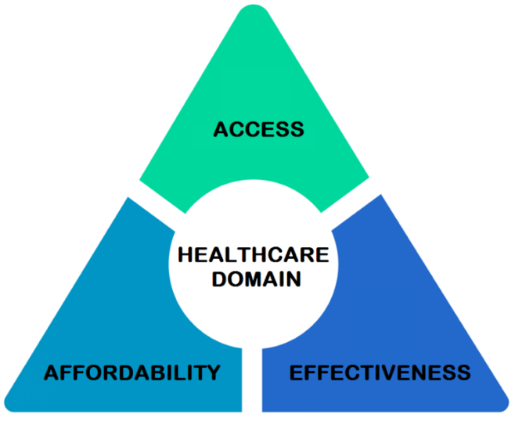With AI gaining prominence in many sectors, the health sector is not far behind. AI has been a transformational factor in changing the lives of many people. Using AI-based services has enabled the medical world to reduce costs and improve the outcomes of treatments.

In the context of the healthcare domain, there is an ‘iron triangle’ within which three factors are at play and affect each other. These factors are – access, affordability, and effectiveness. If one tries to improve any one of these factors, the other two automatically are also affected.

Fig 5.7: 3-Factor Iron Triangle

However, using AI can assist in solving the dilemma to a great extent. The inclusion of AI can help the medical world in services that were earlier rendered by humans such as diagnosis, thereby reducing the cost of the treatment, to a greater extent. Similarly, AI can help diagnose at-least 20% of the total un-treated patients who are unable to avail themselves of medical services. Also, AI has been able to bridge the gap between healthcare providers, hospitals, and drug manufacturers to assist in making medicines readily available even in the remote corners of the world.

Operation Smile is an international medical charity that has provided thousands of free surgeries for children and young adults in developing countries who are born with a cleft lip, cleft palate, or other dental and facial conditions.



Fig 5.8: A child with a cured cleft lip condition, post operation

<https://news.microsoft.com/transform/operation-smile-dignity-children/>

Together with Microsoft’s Pix, an app and a facial modeling algorithm, Operation Smile has helped scores of children with cleft lip and palate conditions. A combination of the two results in better surgical outcomes, bringing smiles to the faces of thousands of children. Microsoft Pix is a smart camera app that automatically helps take better photos without extra effort. Microsoft Pix has been included as one of the 2019s Best Apps by the New York Times and one of the 50 Best Apps of the Year by TIME.

Questions to Ponder Upon

1. What could be probable areas where AI services could be used for the benefit of the mankind?
2. Can AI be used to prematurely detect children with learning disabilities in order to start corrective measures, early in their life?
3. According to you, can AI bridge the gap between organ recipient and organ donor without the middleman?

References

* Aber, J. (2008). History of maps and cartography. [online] Academic.emporia.edu. Available at: http://academic.emporia.edu/aberjame/map/h_map/h_map.htm [Accessed 24 Oct. 2019].
* Ethnologue (2019). *How many languages are there in the world?*. [online] Ethnologue. Available at: https://www.ethnologue.com/guides/how-many-languages [Accessed 24 Oct. 2019].
* Ethnologue 1 (2019). *How many languages are endangered?*. [online] Ethnologue. Available at: https://www.ethnologue.com/guides/how-many-languages-endangered [Accessed 24 Oct. 2019].
* Hospers, J. (2019). *Philosophy of art - The interpretation of art*. [online] Encyclopedia Britannica. Available at: https://www.britannica.com/topic/philosophy-of-art/The-interpretation-of-art [Accessed 24 Oct. 2019].
* Lin, S. (2019). *Art and Interpretation | Internet Encyclopedia of Philosophy*. [online] Iep.utm.edu. Available at: https://www.iep.utm.edu/artinter/ [Accessed 24 Oct. 2019].
* Microsoft (2018). *The Mont Saint-Michel: Digital perspectives on the model | Microsoft In Culture*. [online] Microsoft In Culture. Available at: https://www.microsoft.com/inculture/arts/le-mont-saint-michel-mixed-reality/ [Accessed 24 Oct. 2019].
* Microsoft (2019). *How AI is changing arts and culture*. [online] MICROSOFT. Available at: https://news.microsoft.com/on-the-issues/2019/07/30/ai-changing-arts-culture/ [Accessed 24 Oct. 2019].
* Microsoft Translator (2015). *Microsoft Translator Introduces Yucatec Maya and Querétaro Otomi for UNESCO's International Mother Language Day - Microsoft Translator Blog*. [online] Microsoft Translator Blog. Available at: https://www.microsoft.com/en-us/translator/blog/2015/02/23/microsoft-translator-introduces-yucatec-maya-and-quertaro-otomi-for-unescos-international-mother-language-day/ [Accessed 24 Oct. 2019].
* Saeed, F. (2017). *9 Powerful Examples of Artificial Intelligence in Use Today - IQVIS Inc.*. [online] IQVIS Inc. Available at: https://www.iqvis.com/blog/9-powerful-examples-of-artificial-intelligence-in-use-today/ [Accessed 24 Oct. 2019].
* Operation Smile Website (2019). About Us. [Online] Operation Smile. Available at: https://www.operationsmile.org/content/about-us [Accessed 29 Oct. 2019].
* Shirol, S. (2018). Sociocultural beliefs and perceptions about cleft lip-palate and their implications in the management, outcome, and rehabilitation. Journal of Cleft Lip Palate and Craniofacial Anomalies, 5(1), p.4.
* St. Louis Children's Hospital (2019). Cleft Lip and Palate in Children: Causes, Symptoms, Diagnosis and Treatment | St. Louis Children’s Hospital. [Online] Stlouischildrens.org. Available at: https://www.stlouischildrens.org/conditions-treatments/cleft-lip-and-palate [Accessed 30 Oct. 2019].
* Dodds, L. (2019). *AI could bring an end to famine, says World Bank president*. [online] The Telegraph. Available at: https://www.telegraph.co.uk/technology/2018/10/03/ai-could-bring-end-famine-says-world-bank-president/ [Accessed 30 Oct. 2019].
* Jungcurt, S. (2018). *Global Coalition to Use Technology, Data and AI to Predict and Prevent Famines | News | SDG Knowledge Hub | IISD*. [online] Sdg.iisd.org. Available at: https://sdg.iisd.org/news/global-coalition-to-use-technology-data-and-ai-to-predict-and-prevent-famines/ [Accessed 30 Oct. 2019].
* Spelhaug, J. (2019). *Helping refugees and displaced persons by shifting the approach to how we help nonprofits - Microsoft on the Issues*. [online] Microsoft on the Issues. Available at: https://blogs.microsoft.com/on-the-issues/2019/06/19/helping-refugees-and-displaced-persons-by-shifting-the-approach-to-how-we-help-nonprofits/ [Accessed 30 Oct. 2019].
* TrialWatch (2019). *TrialWatch® - Clooney Foundation For Justice*. [online] Clooney Foundation For Justice. Available at: https://cfj.org/project/trialwatch/ [Accessed 30 Oct. 2019].
* Microsoft APAC News Center (2019). How technology can combat human trafficking in Asia Pacific - Asia News Center. [online] Asia News Center. Available at: https://news.microsoft.com/apac/2015/12/21/how-technology-can-combat-human-trafficking-in-asia-pacific/ [Accessed 31 Oct. 2019].

Glossary

**Cartography –** The study and the practice of making maps. Combining science, technique and aesthetics, cartography builds on the premise that reality can be modeled in ways that communicate spatial information effectively

**Isolationism** – It is the appreciation of art, without taking into consideration the contextual knowledge of the artist’s biography, historical background, and other factors that may have affected the art.

**Contextualism** – It is the appreciation of art in the context of the artist’s biography, historical background, and other factors that may have affected the art.



